Chapter 10, Problem 76.

Determine V_{o} and I_{o} in the op amp circuit of Fig. 10.119.

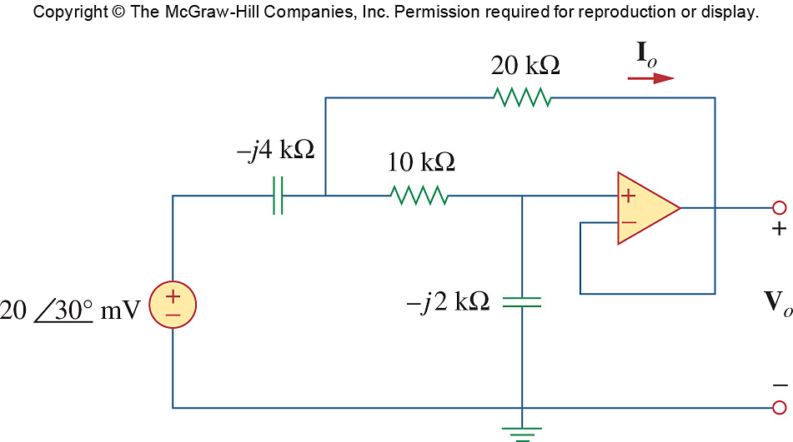
2∠30° V

Figure 10.119
For Prob. 10.76.

